

**CSIS2044**

**NETWORKING AND DISTRIBUTION SYSTEM**

**ASSIGNMENT**

|  |  |
| --- | --- |
| **Name:** | KHEW HUI XIN |
| **Student ID:** | D190326C |
| **Batch:** | CS19-C |
| **Lecturer:** | Madam Shaffika bte Mohd Suhaimi |
| **Semester:** | 2021B - June 2021 |

**Title:** Creating a Peer-to-Peer Network with an Ethernet Cable

**Introduction/Purpose:**

A peer-to-peer network is created when two or more peers are connected and sharing resources directly without the involvement of a server. The peers can be desktops, laptops, etc.

An Ethernet cable is used to create high-speed wired network connections between two devices. A crossover cable is a type of CAT 5 cable with one end of T568A configuration and another end with T568B configuration. A CAT 5 or category 5 cable is a network cable that consists of four twisted pairs of copper wire terminated by an RJ-45 connector. The internal wiring of a crossover cable reverses the transmission and receive signals. A crossover cable is used to connect two devices of the same or similar type directly. For example, connecting two computers. A straight-through cable is also a type of CAT 5 cable. However, both ends of a straight-through cable will have the same standard, either the T568A or T568B standard. This type of cable is used to connect different types of devices. For example, connecting computer to a switch.

Physical layer is the first and lowest layer of the OSI model. It defines the relationship between a device and a transmission medium. At this layer, end devices must be connected by medium such as a copper cable. Meanwhile, network layer is layer 3 of the OSI model. Internet protocol or IP is the most important protocol of layer 3. In the Internet, IP addresses are unique addresses used to identified devices. They allow the data to be delivered to the designated device.

This aim of this lab is to form a peer-to-peer network between two PCs of the same type with an Ethernet cable. This lab will examine either peer-to-peer network between two PCs of the same type can be formed by using crossover cable or straight-through cable, or both cables can be used to form the network. The PCs will first be directly connected with crossover cable and have their connectivity being verified, then they will be directly connected with straight-through cable and have their connectivity being verified. The crossover cable being used in this lab is copper crossover cable, while the straight-through cable being used in this lab is copper straight-through cable.

IP addresses are also needed when directly connecting two computers with an Ethernet cable. Hence, the IP addresses need to be set before the connectivity between the PCs can be verified.

**Hypothesis:**

The peer-to-peer network will be created successfully when the PCs are cabled with a crossover cable, while the peer-to-peer network is not formed when the PCs are cabled with a straight-over cable.

**Materials:**

1. Two PCs of the same type
2. A copper crossover cable
3. A copper straight-through cable

**Procedures:**

1. Add the two PCs onto the white space.

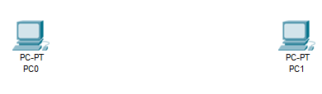

1. Set the IP address for both PCs:
2. Click on PC0. On the popup window, click on the “IP Configuration”.
3. Fill in the IP address “192.168.1.2” in the “IPV4 Address” field. Press the tab key on the keyboard and the subnet mask field will be filled in automatically as “255.255.255.0”. If it is not filled in automatically, then we need to fill in the address manually.

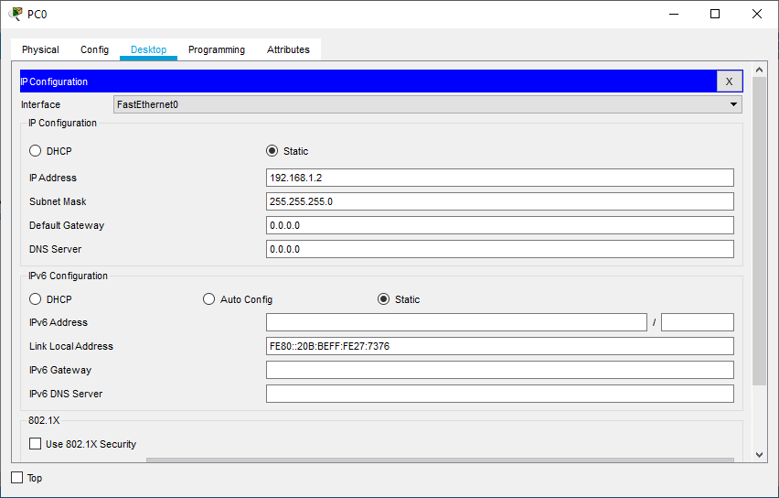

1. Close the window.
2. Repeat step 2(i) to 2(iii) for PC1. The IP address for PC1 will be “192.168.1.3” and the subnet mask will be “255.255.255.0”, which is the same with PC0.

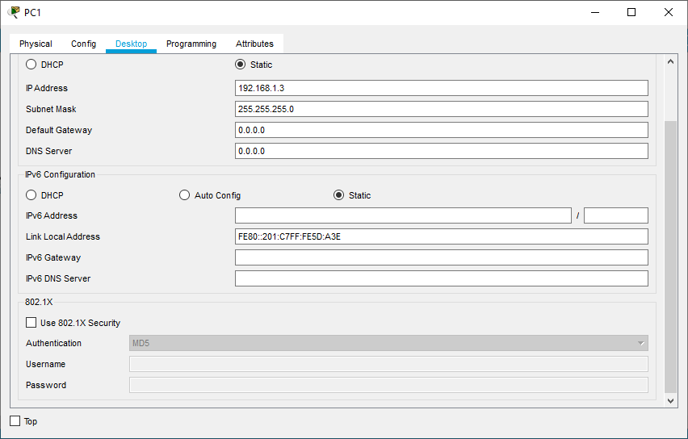

1. Select the copper crossover cable, click on the icon of PC0, and select the “FastEthernet0” to plug the cable into PC0. Click on the icon of PC1 and again select the “FastEthernet0” to plug another end of the cable into PC1.

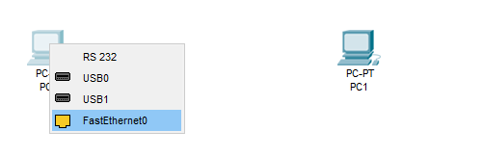

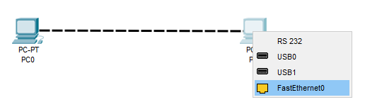

1. Verify the connectivity.

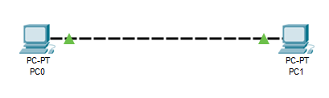

1. Click on PC0. On the popup window, click on the “Command Prompt”.
2. Type “Ping 192.168.1.3”. (192.168.1.3 is the IP address of PC1)
3. Repeat step 3 and 4 but change the copper crossover cable with the copper straight-through cable (delete the copper crossover cable and plug the copper straight-through cable into the “FastEthernet0” of both PCs).

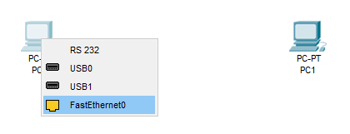

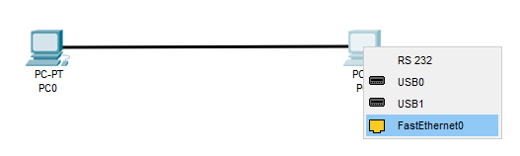

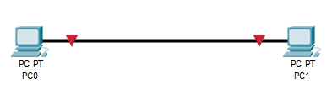

**Results/Data:**

Figure 1. PC0 pinging PC1 with 32 bytes of data (cabled with crossover cable)

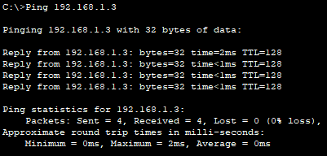

Figure 2. PC0 pinging PC1 with 32 bytes of data (cabled with straight-through cable)

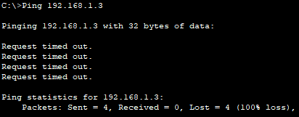

Table 1. The results of PC0 pinging PC1 with 32 bytes of data

|  |  |  |  |
| --- | --- | --- | --- |
| **Type of Cable** | **Packets Sent** | **Packets Received** | **Packets Lost** |
| Copper crossover cable | 4 | 4 | 0 |
| Copper straight-through cable | 4 | 0 | 4 |

Table 2. The connectivity of the two PCs cabled with different cables

|  |  |
| --- | --- |
| **Type of Cable** | **Connection between the two PCs** |
| Copper crossover cable | Success (0% packet loss) |
| Copper straight-through cable | Failed (100% packet loss) |

**Discussions/Data analysis:**

1. According to Figure 1, when the PCs are connected through a copper crossover cable, all packets sent by PC0 were received PC1. Hence, the connectivity of PC0 and PC1 cabled with a copper crossover cable is verified. Peer-to-peer network is formed successfully.
2. According to Figure 2, when the PCs are connected through a copper straight-through cable, all packets sent by PC0 were lost and were not received by PC1. Hence, the connection between PC0 and PC1 cabled with a copper straight-through has failed. Peer-to-peer network is not formed.

**Conclusion/Summary:**

The result of the lab supports the hypothesis. The peer-to-peer network will be created successfully when the PCs are cabled with a crossover cable, while the peer-to-peer network is not formed when the PCs are cabled with a straight-over cable. Hence, a crossover cable is used to connect same or similar devices.

|  |  |  |  |  |
| --- | --- | --- | --- | --- |
| **REPORT RUBRIC** | **Far Below Standard (1)** | **Approaches Standard (2)** | **Meets Standard (3)** | **Exceeds Standard (4)** |
| 2 | 5 | 7 | 10 |
| **Introduction/Purpose** | • Intro is missing more than two elements  • Missing hypothesis and/or  • The reasoning behind hypothesis is missing.  • The purpose of the lab and/or question to be answered  during the lab is erroneous or irrelevant. | • Intro is missing two elements  • Undeveloped or confusing point of view in hypothesis  • The reasoning behind the hypothesis is undeveloped,  unrelated, or unclear.  • The purpose of the lab and/or question to be answered during the lab is partially identified and is stated in a somewhat unclear manner. | • Intro is missing one element  • Consistent and clear perspective in hypothesis  • The reasoning behind the hypothesis is clear, but too  brief.  • The purpose of the lab and/or question to be answered  during the lab is identified but  stated in a somewhat unclear manner. | • Intro is complete with all required elements.  • Clear, thoughtful point of view in hypothesis.  • The reasoning behind the hypothesis is clear, thoughtful,  and complete.  • The purpose of the lab and/or question to be answered during the lab is clearly identified and stated. |
| **Materials** | • Materials list is missing or  • Materials list is incomplete, missing more than three elements: quantities, measurements, or specific details. | • Two or three elements  pertaining to materials are incomplete, unclear, or missing: quantities, measurements, or specific details. | • One element pertaining to materials is incomplete,  unclear, or missing: quantities, measurements, or specific details. | • Materials are complete with quantities, measurements, and specific details. |
| **Procedures**  **(2x)** | • Procedures are missing or contain a minimal number of  the stated requirements  • Procedures do not accurately list the steps of the  experiment.  • Very difficult for others to follow these procedures, as  written. | • Procedures include some of the stated requirements  • Steps are listed but are not in a logical order or are difficult  to follow.  • Others would have some difficulty following the  procedures, as written. | • Procedures include most of the stated requirements  • Steps are written in a logical order but are not numbered  and/or are not in complete sentences.  • Anyone could follow the  procures but might have a question or two. | • Procedures include all stated requirements  • Steps are clearly written, each being numbered and in complete sentences.  • Anyone could easily follow these procedures. |
| **Results/Data**  **(2x)** | • Data/evidence is missing.  • No attempt has been made to organize data/evidence  • Needed diagrams, charts, and/or graphs are missing or  are missing key labels or information.  • No calculations were shown  but were needed OR results were inaccurate. | • Quality and quantity of data/evidence is inadequate to  meet the task.  • Data table is inadequate.  Missing titles, labels, etc.  • Diagrams, charts, and/or graphs are included.  • Some calculations, if  applicable, are shown but some may be inaccurate or results mis-labeled. | • Quality and quantity of data/evidence is adequate to  meet the task  • Data table looks professional, but needs a title or headings,  • or graph axes or #s labeled.  • Data may need to be further processed to aid reader.  • Diagrams, charts, and/or graphs are included and are  labeled neatly and accurately.  • Some calculations, if applicable, are shown and  results are correct and labeled  appropriately. | • Quality and quantity of data/evidence is relevant and accurate.  • Data table looks professional.  • All appropriate math is complete. Titles, headings, and all numbers are labeled.  • Clear and accurate diagrams, charts, and graphs included and  are effective, making the  experiment easier to understand.  • All calculations, if applicable, are shown and results are  correct and labeled appropriately. |
| **Discussion/Data Analysis**  **(2x)** | • Two or more of the required  elements are missing OR  • Discussion is unclear, incomplete, or does not reflect the data presented. | • One of the required elements is  missing (discussion of data, trends, and/or experimental errors) OR  • Two of the required elements is incomplete (discussion not thorough or clear) | • Data is discussed in words,  using complete sentences and logical thoughts.  • Trends and patterns or lack of same are noted.  • Experimental errors are listed. | • Data is clearly and thoroughly discussed in words, using complete sentences and logical thoughts.  • Trends and patterns or lack of same are noted and clearly/thoroughly discussed.  • Experimental errors are listed and a discussion is included as to how they affected the experiment. |
| **Conclusion/Summary** | • Two or more of the required elements are missing: whether  the findings supported the hypothesis, possible sources of  error, or what was learned from the experiment and/or  • Results compared to hypothesis are stated only.  • Connection to physical science unclear.  • Discussion of what was learned was weak. | • Conclusion missing all or part of two of the required  elements: whether the findings supported the hypothesis,  possible sources of error, or what was learned from the  experiment.  • Results compared to hypothesis are stated only.  • More thought needs to be  given to experimental error.  • Connection to physical science is minimal.  • Discussion of what was  learned is weak. | • Conclusion missing all or part of one of the required  elements: whether the findings supported the hypothesis,  possible sources of error, or what was learned from the  experiment.  • Results compared to hypothesis are stated and  supported but could be more  thorough or clear.  • Discusses experimental error and how to improve  experiment’s design, but could  think more critically  • Connection to physical science is present but could be  explained more clearly. | • Conclusion includes whether the findings supported the  hypothesis, possible sources of error, and what was learned from  the experiment.  • Results compared to hypothesis are detailed and supported  clearly and thoroughly.  • Much critical thinking is evident in discussion of experimental error and how to improve the experiment’s design.  • Report clearly connects the experiment to physical science concepts and states what was learned from the process. |
| **Overall Quality** | • Several required elements are missing  • Poorly organized and  presented  • Lack of attention to detail  • More than four errors in spelling, punctuation, or  grammar in the report.  • Vocabulary from grade 8 science is not used. | • Some of the required elements are missing  • Organization and  presentation need improvement  • Some details missing – could  have added to understanding or to improve communication of lab  • Three or four errors in spelling, punctuation, or  grammar in the report.  • Vocabulary from grade 8 science is seldom used. | • One required element is missing  • Organization and  presentation are good  Details are good although being more thorough (i.e.,  with added comments, graphics, or explanation) in  areas would enhance understanding.  • One or two errors in spelling, punctuation, or grammar in  the report.  • In general, vocabulary from grade 8 science is used. | • All required elements are present and additional elements  that add to the report (i.e.,  thoughtful comments, graphics, explanations) have been added  • Organization and presentation  are excellent.  • No errors in spelling, punctuation, or grammar in the  report.  • Vocabulary from grade 8 science is consistently used. |